Title: Crypt Arithmetic

**Ex. No.:** 3 **Reg. No.:** RA2011051010006

**Date:** 02/02/23 **Name:** Vittesh Raghavan

# Aim:

To solve the crypt arithmetic problem. A cryptarithmetic puzzle is a mathematical game where the digits of some numbers are represented by letters (or symbols). Each letter represents a unique digit. The goal is to find the digits such that a given mathematical equation is verified

**Constraints :**

* Each Letter, Symbol represents only one digit throughout the problem.
* Numbers must not begin with zero i.e. 0567 (wrong) , 567 (correct).
* Aim is to find the value of each letter in the Cryptarithmetic problems
* There must be only one solution to the Cryptarithmetic problems
* The numerical base, unless specifically stated , is 10.
* After replacing letters by their digits, the resulting arithmetic operations must be correct.
* Carry over can only be 1 in Cryptarithmetic problems

**Procedure/Algorithm:**

* The goal here is to assign each letter a digit from 0 to 9 so that the arithmetic works out correctly. The rules are that all occurrences of a letter must be assigned the same digit, and no digit can be assigned to more than one letter.
* First, create a list of all the characters that need assigning to pass to Solve
* If all characters are assigned, return true if puzzle is solved, false otherwise
* Otherwise, consider the first unassigned character
* for (every possible choice among the digits not in use)
* make that choice and then recursively try to assign the rest of the characters
* if recursion successful, return true
* if !successful, unmake assignment and try another digit
* If all digits have been tried and nothing worked, return false to trigger backtracking

Program:

# 

# Manual Output: Manual calculation for the example you have taken:

# From Column 5, M=1, since it is only carry-over possible from sum of 2 single digit number in column 4.

# To produce a carry from column 4 to column 5 ‘S + M’ is at least 9 so ‘S=8or9’ so ‘S+M=9or10’ & so ‘O=0or1’ . But ‘M=1’, so ‘0=0’.

# If there is carry from column 3 to 4 then ‘E=9’ & so ‘N=0’. But ‘O=0’ so there is no carry & ‘S=9’ & ‘c3=0’.

# If there is no carry from column 2 to 3 then ‘E=N’ which is impossible, therefore there is carry & ‘N=E+1’ & ‘c2=1’.

# If there is carry from column 1 to 2 then ‘N+R=E mod 10’ & ‘N=E+1’ so ‘E+1+R=E mod 10’, so ‘R=9’ but ‘S=9’, so there must be carry from column 1 to 2. Therefore ‘c1=1’ & ‘R=8’.

# To produce carry ‘c1=1’ from column 1 to 2, we must have ‘D+E=10+Y’ as Y cannot be 0/1 so D+E is at least 12. As D is at most 7 & E is at least 5(D cannot be 8 or 9 as it is already assigned). N is atmost 7 & ‘N=E+1’ so ‘E=5or6’.

# If E were 6 & D+E atleast 12 then D would be 7, but ‘N=E+1’ & N would also be 7 which is impossible. Therefore ‘E=5’ & ‘N=6’.

# D+E is atleast 12 for that we get ‘D=7’ & ‘Y=2’.

Solution:

9 5 6 7  
+ 1 0 8 5  
----------  
1 0 6 5 2

# Screenshot of output: Actual Output you get after executing your program:

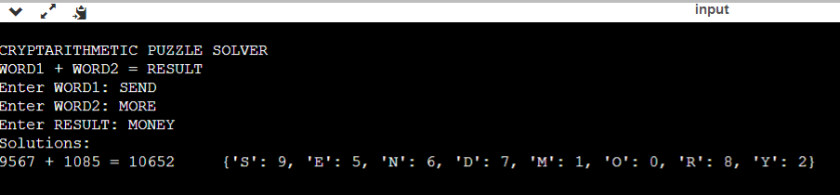

**Result:**

Crypt Arithmetic Problem was executed and solved successfully .